

GRIDTALK™
GridTalk Installation Guide
for Windows

Release version 4.2

Document Updated : 20 Apr 2012

About CrimsonLogic eTrade Services
CrimsonLogic eTrade Services is a wholly-owned subsidiary of CrimsonLogic Pte Ltd. Established with the mission to serve the trade and logistics sector, we offer innovative and secure eTrade services to facilitate businesses to complete critical trade documentation and communication quickly and accurately. We enable businesses to connect and collaborate with their global trading partners seamlessly in a secure environment.

We have developed a suite of products under TradePalette®. TradePalette® is an end-to-end electronic trade management solution that enables the exchange and sharing of information for seamless business communications. It facilitates businesses in their business-to-business (B2B) and business-to-government (B2G) trade communication, coordination and collaboration, resulting in significant cost and time savings.

Our other core business is TradeWeb™ which streamlines the cargo declaration process by enabling users to send declarations to the Singapore Customs, IE Singapore, and other controlling agencies directly from the computer. The whole process of launching a cargo declaration to printing of a Cargo Clearance Permit (CCP) can be completed within minutes through the use of Trade Declaration services.

With a call centre in operation 24x7, our dedicated helpdesk serves as the business support centre for customer enquiries and troubleshooting. Our data centre infrastructure provides disaster recovery services to ensure that our customers’ data is protected and can be retrieved quickly to resume operations.

Proprietary Information
This Admin Guide contains information, which is proprietary to CrimsonLogic eTrade Services Pte Ltd. No part of this Admin Guide may be reproduced in any material form (including photocopying or storing it in any medium by electronic means and whether or not transiently or incidentally to some other use of this publication) without the written permission of CrimsonLogic eTrade Services Pte Ltd except in accordance with the Copyright Act of Singapore (Cap. 63).

GridTalk™
GridTalk Installation Guide

Contents

Chapter Page

1. About this GridTalk 4.2 Installation Guide 1
1.1. Related Documentation 1
1.2. Typographical conventions 2
2. System requirements 3
2.1. Pre-Setup 3
3. Installing GridTalk 4.2 4
3.1. To download and install GridTalk 4.2 for the first time 4
3.1.1. Windows Executable 4
3.1.2. Windows Zip Installation 13
3.2. Running GridTalk 4.2 15
3.2.1. Starting GridTalk 4.2 15
3.2.2. Shutting down GridTalk 4.2 17
4. Maintenance of GridTalk 4.2 18
4.1. To uninstall GridTalk 18
4.2. To re-install GridTalk 23
4.3. To setup GridTalk Archive Utility 23
4.4. To setup GridTalk Housekeep Utility 23
4.5. To backup GridTalk 23
4.6. To startup the backup GridTalk 24
4.7. To setup GridTalk running as Window services 26
4.7.1. To setup PostgreSQL Database as window services 27

About this GridTalk 4.2 Installation Guide

The GridTalk 4.2 Installation Guide covers the installations such as:

- GridTalk 4.2 software is distributed as an EXE file or zip file for Windows OS.

- The installation should be done using InstallJammer. InstallJammer is an easy-to-use installer that deploys and configures GridTalk automatically on any platform.

Take note that your vendor or system integrator will provide you the correct information for the Product Registration and connection level configuration. This information is unique to your copy of GridTalk 4.2 and necessary for the proper functioning of the software.

Related Documentation
The following documents directly support GridTalk:
- GridTalk 4.2 Administration Guide
- GridTalk 4.2 User Guide

Typographical conventions

The guide uses the following typographical conventions for Windows users.

Convention |  | Example
Procedures are described as a series of numbered steps. |  | - Click the Create icon on the main toolbar.  - Click the Browse button.

System requirements

The recommended system requirements for GridTalk 4.2 are:

For Windows operating system,

Dedicated Server
- CPU: Intel Dual Core 2 Ghz (recommend Xeon or equivalent and higher)
- RAM: 2 GB (recommend 4 GB)
- Hard disk: 20 GB (depends on amount of historical transactions storage)
- Windows
- IE 6.0, 7.0, 8.0, Firefox 1.5 or later, Chrome 10

Virtual Machine
- CPU: 2x Virtual CPU of 2.6 GHz each (recommend Xeon or equivalent and higher)
- RAM: 2 GB (recommend 4 GB)
- Hard disk: 20 GB (depends on amount of historical transactions storage)

Pre-Setup

Before setting up GridTalk 4.2, you have to ensure that the following checks be done accordingly:

- No existing PostgreSQL Database with version 8.2 is installed. This can be validated by checking the Add or Remove Programs under Control Panel.
- The ports used by GridTalk are described as tabulated below. Check that they are not used by other active applications:

Port used | Purpose
31098 | Listening port Java RMI Naming service used by the EJB application server.
31099 | Listening port for Java Naming Service used by the EJB application server.
35432 | PostgreSQL access port. Local access only.
9099 | GridTalk Console port
8080 | RosettaNet HTTP port
443 | RosettaNet HTTPS port
8009 | AJP connection port (for connection to Apache server)
6763 | GridTalk backend connector listening port
6767 | Backend Receiver listening port. Used for backend configuration if applicable
5001 | GridTalk Backend Webservice monitoring port
4444 | Internal JBoss port (RMI)
4445 | Internal JBoss port (Pool management)
8083 | Internal JBoss port (Web services)
8093 | Internal JBoss port (JMS services)
12345 | Listening port for logging GridTalk activities.

Installing GridTalk 4.2

GridTalk 4.2 should be installed on a server or PC with Internet access. (See 2.1 for the minimum and suggested system and hardware requirements.)

To download and install GridTalk 4.2 for the first time

After you have downloaded the installer files from the CD-ROM distributed to you, ensure that you have GridTalk 4.2 installer for the installation process.

Take note that your vendor will provide you with your node information like GridNode Name, GridNode ID, License Key, etc.

Windows Executable

- Double click on the GridTalk4.2.X_jBoss_win.exe file saved on your computer to begin the installation process. You will be prompted to select the installation language.

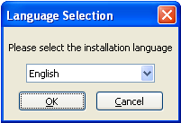

- Select the installation language as English and Click Ok. Then you will be prompted for confirmation on installing GridTalk.

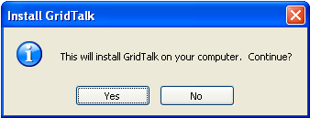

- Click Yes. Then you will be greeted by this Welcome window like this:

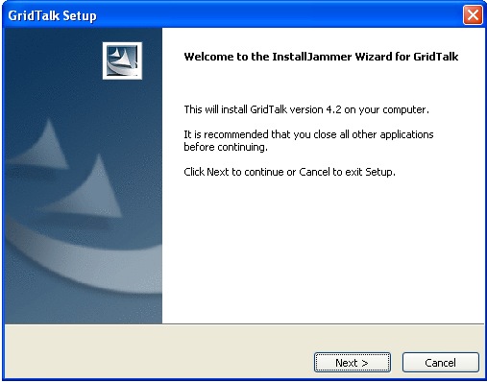

- Click Next to install GridTalk 4.2. Then you will be prompted to read and accept the License Agreement. To accept the terms of the License agreement, click on its radio button. Click Yes.

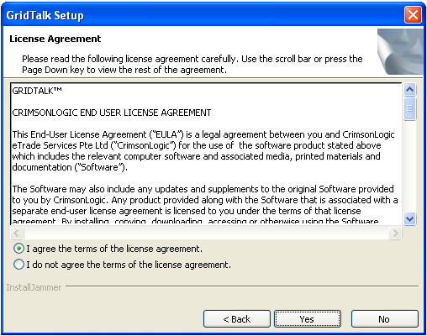

- As the Choose Install Folder window appears, select the destination folder to install GridTalk 4.2. Alternatively, click Choose Folder to select the destination folder you want. Once you are finished with creating that folder, click Next.

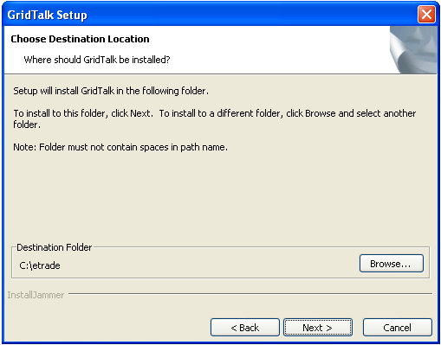

Take note that if you already have the existing GridTalk before installing it, you will be prompted by this screen below.

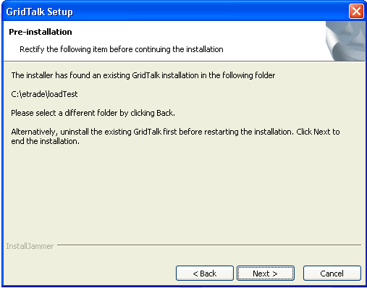

Similarly, if there is an existing GridTalk PostgreSQL DB services is currently installed, you will be prompted by this screen below.

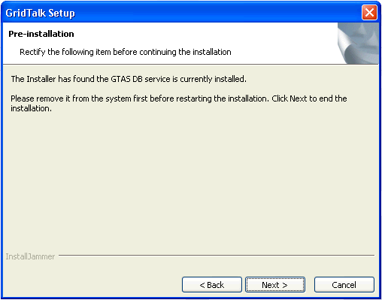

Click Next to end the installation of the GridTalk.

- To uninstall GridTalk, refer to section 4.1 To uninstall GridTalk.
- To uninstall the existing GridTalk PostgreSQL DB, refer to Step 1 of section 4.1 To uninstall GridTalk.

- The GridTalk Setup type window appeared. Select the setup type as Typical and Click Next.

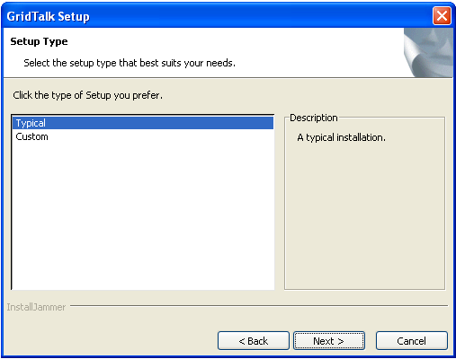

- The GridTalk Setup Summary window appears, showing you the summary of your installation settings. Click Install to start the installation.

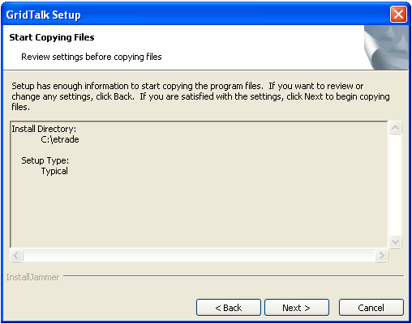

- As the installation begins, InstallJammer deploys the main applications such as Java Runtime Environment, JBoss, Postgres, Ant, etc.

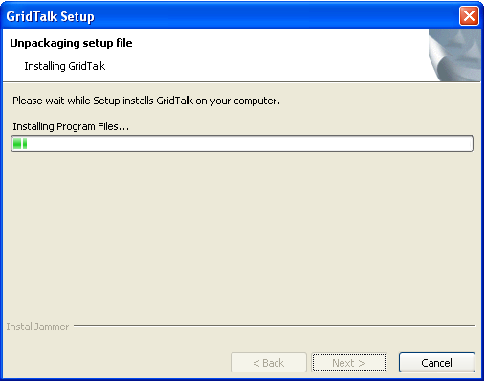

- Once the GridTalk 4.2 is successfully installed, click Finish to complete the installation process. Take note that the Launch GridTalk, Create Desktop Shortcut and the View Release Notes checkbox is default as ticked. If you do not wish to execute one of the listed option, just un-tick the corresponding checkbox.

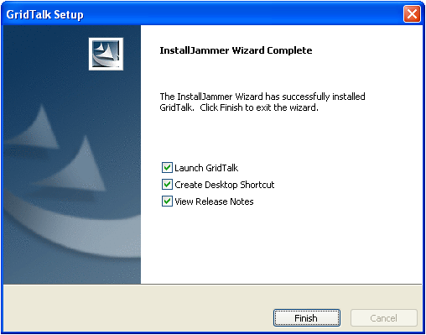

- At the end of installation process, the GridTalk shortcut folder will be created under Desktop (If the Create Desktop Shortcut is selected in the previous step) and the Program Files folder (C:\Program Files\CrimsonLogic eTrade\GridTalk) to contain its contents as shown below.

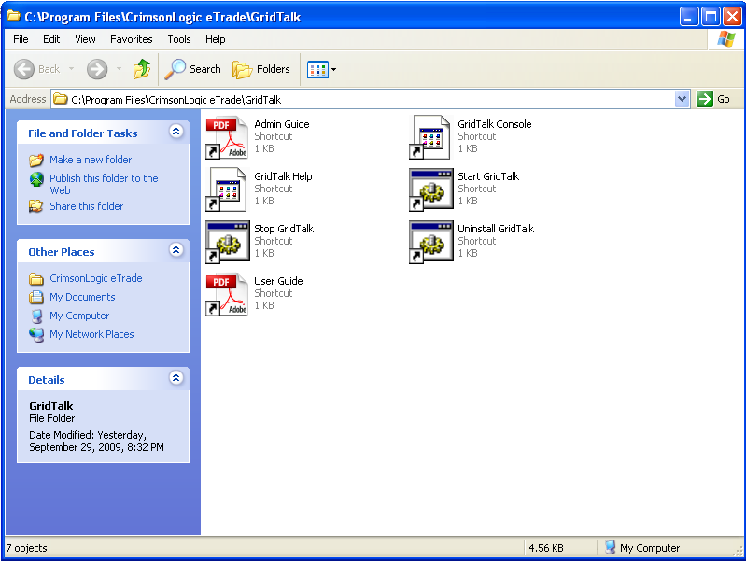

The shortcut icons serve the following purposes:

Shortcut icon name | Purpose
Start GridTalk | To startup the GridTalk application.
Stop GridTalk | To shutdown the GridTalk application.
GridTalk Console | To launch the GridTalk Console webpage on the system default Internet browser.
GridTalk Help | To launch the GridTalk Online Help webpage on the system default internet browser.
User Guide | To open up the GridTalk User Guide in the system pre-installed Adobe Acrobat Reader.
Admin Guide | To open up the GridTalk Administration Guide in the system pre-installed Adobe Acrobat Reader.
Uninstall GridTalk | To start the uninstallation wizard for GridTalk.

- Proceed to the next chapter for details on using the GridTalk application.

Windows Zip Installation

- Unzip the package GridTalk4.2.X_jBoss_windows_full.zip to the install directory (EG. C:\etrade)

- Set the System variables GRIDTALK_HOME by pointing to the root directory of GridTalk installation (EG. C:\etrade\GridTalk)

- Proceed to the next chapter for details on using the GridTalk application.

If GridTalk is installed under an Administrator account, the PostgreSQL DB will not be started up successfully. This is due to the PostgreSQL DB is designed to run under non administrator account. To overcome such cases, do follow the steps below.

- Refer to section To setup PostgreSQL Database as window services

- Grant permission to the user “gtasPostgres” we created previously to have modify/write access to the folder %GRIDTALK_HOME%\db

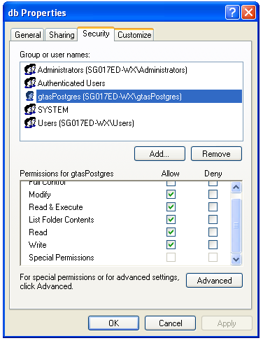

If GridTalk is installed under non-administrator account, we need to modify the following configuration file

- Edit the file “setenv.bat” under folder %GRIDTALK_HOME%\bin\

- Locate the following section in file “setenv.bat”

rem database specific environment settings
set DB_STARTUP_CMD=startPostgres.bat
set DB_SHUTDOWN_CMD=stopPostgres.bat

- Append the system variable %GRIDTALK_HOME% behind the entries DB_STARTUP_CMD and DB_SHUTDOWN_CMD respectively as below.

rem database specific environment settings
set DB_STARTUP_CMD=startPostgres.bat %GRIDTALK_HOME%
set DB_SHUTDOWN_CMD=stopPostgres.bat %GRIDTALK_HOME%

Running GridTalk 4.2

After GridTalk 4.2 has been successfully installed, you may proceed to startup the application for first-time product registration and configuration.

Starting GridTalk 4.2

Before starting up GridTalk 4.2, make sure that the GRIDTALK_HOME system environment variable is correctly pointing to the installed folder.

    - To start GridTalk 4.2, go to the folder %GRIDTALK_HOME%\bin via the window explorer.

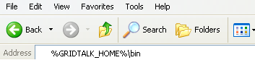

- From the various shortcut icons listed, double-click “startup.bat”. The command prompt window appears. At the same time, the C:\WINNT\System32\cmd.exe background window shows up.

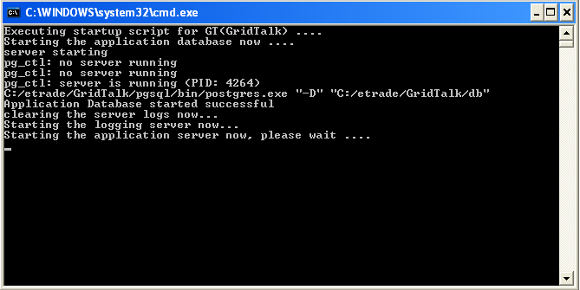

For a system configuration similar to the recommended configuration (section 2.1), the startup time takes about three minutes.

- Go to the GridTalk folder on the desktop, and double-click the “GridTalk Console” shortcut icon. This will open up your default internet browser and go to this website address:

http://localhost:8080/gridtalk

Take a few moments to wait until the GridTalk application browser appears like this:

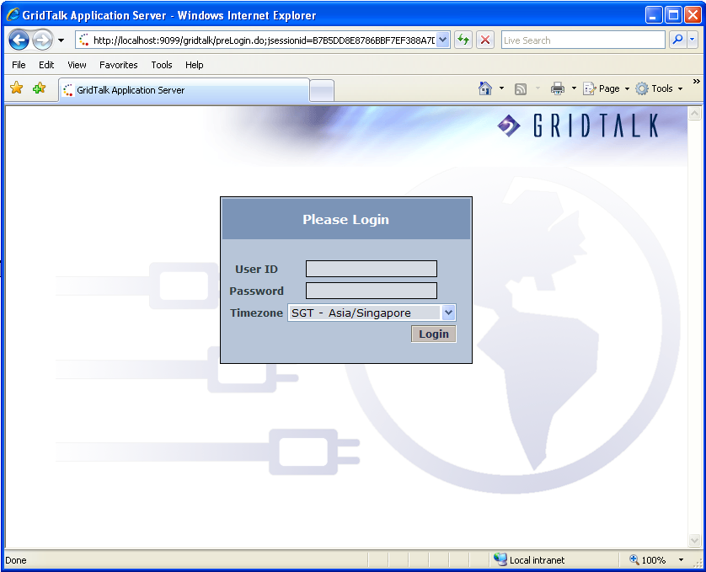

- To log into GridTalk for the first time, enter user name and password. For the first-time registration, refer to GridTalk 4.2 Administrator Guide.

Shutting down GridTalk 4.2

Before shutting down GridTalk 4.2, make sure that you have logged out of the GridTalk 4.2 application browser first.

- Click on the Logout hyperlink from GridTalk Application Server console to log out of the application.

- Go to the folder %GRIDTALK_HOME%\bin via the window explorer and double-click the “shutdown.bat” shortcut icon. The command prompt window appears. At the same time, another C:\WINNT\System32\cmd.exe background window shows up. Wait for a few moments until the shutdown process is completed.

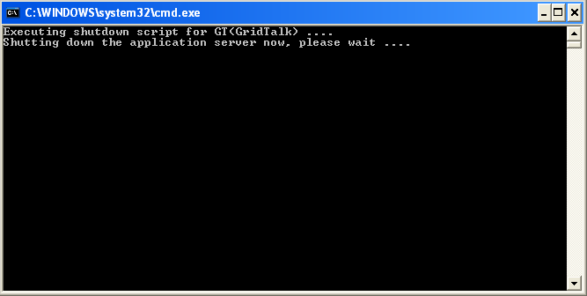

Maintenance of GridTalk 4.2

To uninstall GridTalk

If you don’t intend to use the existing GridTalk, you need to uninstall it by doing the following:

Take note that make necessary backup of the existing GridTalk if required before any un-installation of the GridTalk.

- Ensure that GridTalk is not started or running, if so, shut it down by following the steps in section 3.2.2.

- Go to the Add or Remove Programs under Control Panel to uninstall the PostgreSQL 8.2.

  - Select the “PostgreSQL 8.2” from the list of installed programs, and click on Remove.

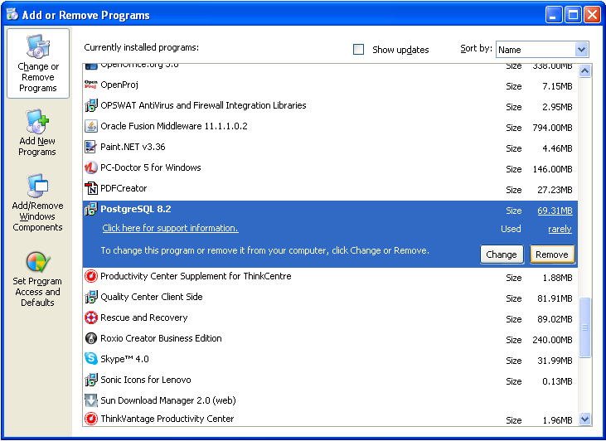

  - Click Yes when Windows prompt you for confirmation on removing the PostgreSQL from your computer.

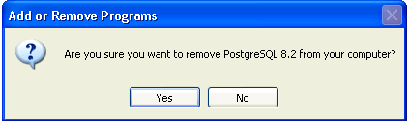

The PostgresSQL 8.2 is uninstalled from your computer.

- Go to the Computer Management under Control Panel\Administrative Tools to remove the GridTalk PostgreSQL Account.

- On the left hand side panel, select the section Local Users and Groups under System Tools.
- Expand the section Local Users and Groups and select the folder Users. A list of available user name will be showed on the right hand side panel as below.

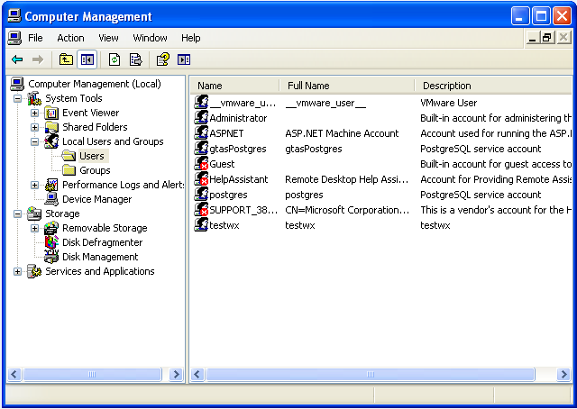

- Select the username “gtasPostgres” and delete it from the system. Select Yes when Windows prompt for confirmation on deleting the user “gtasPostgres”.

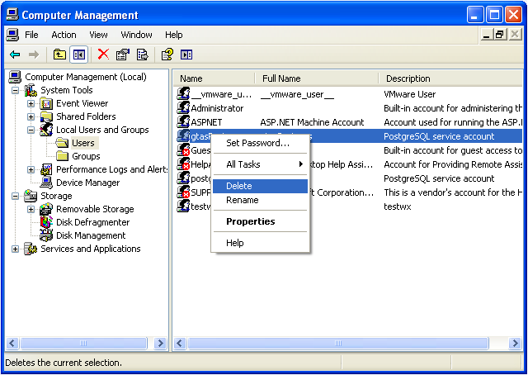

The user account “gtasPostgres” is removed from the Windows.

- Go to the folder Documents and Settings to remove the folder associated with the window user account “gtasPostgres”. In this case, the folder is “gtasPostgres”.

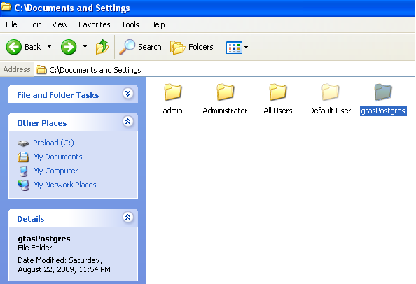

- Go to the GridTalk folder (%GRIDTALK_HOME%), and remove the folder “DB” associated with the PostgresSQL database.

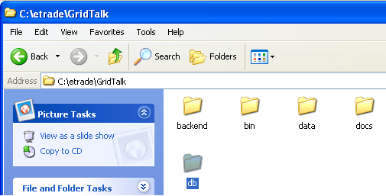

- Go to the Installation root folder of GridTalk via Windows Explorer (One level up from the %GRIDTALK_HOME%, the default directory is under c:\etrade)

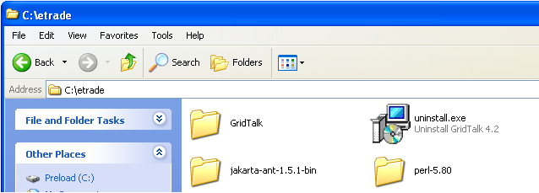

- Double-click the “uninstall.exe”. The Uninstaller Wizard will be showed as below.

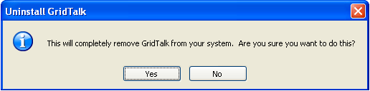

- Click Yes to confirm the un-installation of GridTalk. The un-installation window will be showed indicating the progress of the un-installation.

Note: if the installer indicated that the un-installation is failed due to some file can not be removed, restart your computer and Repeat the un-installation process from Step 6.

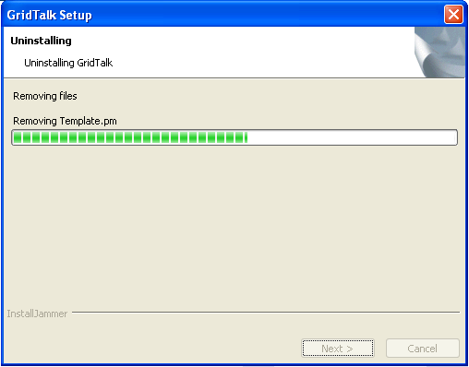

- Select Finish to end the Un-installation wizard.

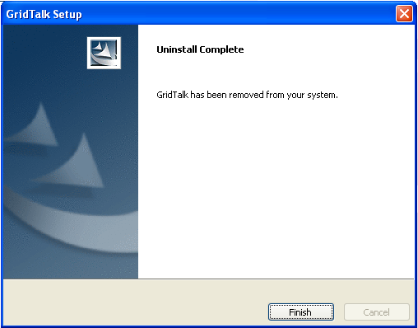

To re-install GridTalk

- Download the new GridTalk 4.2 installer to your directory.

- Double-click GridTalk4.2.x_jBoss_win.exe, which has been saved in your directory.

- Repeat the same procedure as described in Chapter 3.

To setup GridTalk Archive Utility
After GridTalk has been running for quite a long time, a lot of transaction data will be accumulated in the application. Usually such transaction data will not be needed by the user frequently and it is recommended to archive out those data to improve the overall efficiency of the application.

GridTalk has come with the archival utility that helps to extract out those outdated transaction data. Currently, the archival utility comes with two running modes. The first one is ad hoc archive and the second one is recurrence archive.

Given the recommended machine spec in the Chapter 2 Requirement, the suggested maximum historical Process Instances to be kept in the system is 50K. It ensures the GridTalk still in optimal performance.

Refer to Chapter 13.1 Archiving Documents and Processes and Chapter 13.3 Scheduling Archive jobs of GridTalk 4.2 Administration Guide for more detail.

To setup GridTalk Housekeep Utility
When GridTalk processes the transaction data either from Trading Partner or from your backend system, temp files will be generated for intermediate usage. At the same time, log files will be generated as well to keep track the overall activities that are currently performed by the application.

It is necessary to housekeep those temp files and log files to prevent the overgrowth of those files. Hence, the housekeep utility helps better disk utilization and improves the overall application performance as well.

It is recommended that the housekeep utility should be scheduled to run during non-peak hour for example during the weekend or midnight to maximize the performance of the application.

The recommended maximum age of the temp files to be kept in the application are not more than 1 day old. In this case, specify value 1 in “Temporary Files” field under Housekeeping configuration. For log files, we can follow the default value that is 14 days.

Refer to Chapter 13.4 Scheduling housekeeping jobs of GridTalk 4.2 Administration Guide for more detail.

The GridTalk temp folder and log folder is kept under %GRIDTALK_HOME%\data\GNapps\temp and %GRIDTALK_HOME%\logs respectively.

To backup GridTalk
To backup the GridTalk, it involves the simply file copy to a different folder or to a different machine across the network.

Follow the steps below to backup the GridTalk.

- Go to the installation directory of GridTalk (The default directory is under c:/etrade) in Window explorer.

- Copy the folder “jakarta-ant-1.5.1-bin”, “perl-5.80”, “GridTalk” and the file “uninstall.exe” to the directory you do the backup.

Do note that the GridTalk temp folder (under %GRIDTALK_HOME%\GridTalk\data\GNapps\temp) can be excluded for the backup.

To startup the backup GridTalk
Under some circumstance for example Production server is under urgent maintenance, you may wish to startup the backup GridTalk to ensure the business transaction with your trading partner is not interrupted.

Pre-requisite
- Retrieve the running sequence numbers from the Production database.

- Access the Production GridTalk postgres folder (%GRIDTALK_HOME%\pgsql\bin) using the command prompt.
- Execute the script below to login to the PostgreSQL command console. Enter the db password “gtasdb” when you are prompted.

psql --username postgres --port 35432 --dbname gtdb

- Execute the script below to retrieve the current production running number of the following records. Do record down the returned value of each query.

  - rtprocess – it is the running number for the Process Instance (EG gwf://<ID>:Invoice)
  - rtprocessdoc – it is the running number for the rtprocessdoc entity
  - rn_profile – it is the running number for the rn_profile entity
  - import – it is the running number for the GDOC entity under Import Folder
  - export – it is the running number for the GDOC entity under Export Folder
  - inbound - it is the running number for the GDOC entity under Inbound Folder
  - outbound - it is the running number for the GDOC entity under Outbound Folder

set search_path='appdb';

select * from "referencenum" where "RefName"='"rtprocess"';
select * from "referencenum" where "RefName"='"rtprocessdoc"';
select * from "referencenum" where "RefName"='"rn_profile"';
select * from "referencenum" where "RefName"='Import';
select * from "referencenum" where "RefName"='Export';
select * from "referencenum" where "RefName"='Inbound';
select * from "referencenum" where "RefName"='Outbound';

- Enter the following to quit the PostgreSQL command console.

\q

Follow the steps below to startup the backup GridTalk
- Set the %GRIDTALK_HOME% System Variable with the GridTalk backup folder path (Skip if it has been set).

- Edit the “setenv.bat” under %GRIDTALK_HOME%/bin by locating the following properties (Skip if the db is setup as window services or such file has been modified before).

set DB_STARTUP_CMD=startPostgres.bat
set DB_SHUTDOWN_CMD=stopPostgres.bat

Append the system variable %GRIDTALK_HOME% behind the properties as below.

set DB_STARTUP_CMD=startPostgres.bat %GRIDTALK_HOME%
set DB_SHUTDOWN_CMD=stopPostgres.bat %GRIDTALK_HOME%

- Increase the running sequence of the records by following the instruction below.

Note: If we do not increase the “rtprocess” running sequence number, the Trading Partner will receive the duplicate Process Instance as the running sequence number within the backup GridTalk is already used in the production GridTalk.

- Start the GridTalk DB.
- Access the backup GridTalk postgres folder (%GRIDTALK_HOME%\pgsql\bin) using the command prompt.
- Execute the script below to login to the PostgreSQL command console. Enter the db password “gtasdb” when you are prompted.

psql --username postgres --port 35432 --dbname gtdb

- After you login to the PostgreSQL command console, run the SQL command below to update the running number. All the running numbers we recorded down in the Pre-requisite step will be increased by 50.

set search_path=’appdb’;

update "referencenum" set "LastRefNum"='<Production rtprocess running num + 50>' where "RefName"='"rtprocess"';

update "referencenum" set "LastRefNum"='<Production rtprocessdoc running num + 50>' where "RefName"='"rtprocessdoc"';

update "referencenum" set "LastRefNum"='<Production rn_profile running num + 50>' where "RefName"='"rn_profile"';

update "referencenum" set "LastRefNum"='<Production Import running num + 50>' where "RefName"='Import';

update "referencenum" set "LastRefNum"='<Production Export running num + 50>' where "RefName"='Export';

update "referencenum" set "LastRefNum"='<Production Inbound running num + 50>' where "RefName"='Inbound';

update "referencenum" set "LastRefNum"='<Production Outbound running num + 50>' where "RefName"='Outbound';

- Enter the following to quit the PostgreSQL command console.
\q

- Start up the backup GridTalk as per normal by executing startup.bat under %GRIDTALK_HOME%\bin.

To setup GridTalk running as Window services
GridTalk can be configured to be running as Window services. By setting up the application running services, it enables the application to be automatically started when the computer is booted. It also enables multiple users working on the same computer without interfere the running GridTalk.

Follow the step below to configure GridTalk running as services

- Ensure GridTalk has been shutdown.

- Go to the folder %GRIDTALK_HOME%\bin\admin via command prompt.

- Execute the batch file “service.bat”.

- When prompting for option, enter “i” as below.

Please select an option
[I]. Install and Start the Services [GridTalk_Logger, GridTalk_AS]
[R]. Stop and Remove the Services [GridTalk_Logger, GridTalk_AS]

[I,R]?i

- The GridTalk service is configured successfully and will be started up.
Installing and start GridTalk_Logger as Windows service
------------------------------------------------------

The GridTalk_Logger automatic service was successfully installed.
Starting the "GridTalk_Logger" service ...

The GridTalk_Logger service is starting.
The GridTalk_Logger service was started successfully.

Installing GridTalk_AS as Windows service
-----------------------------------------

The GridTalk_AS automatic service was successfully installed, depends on pgsql-8.2 service.
Starting the "GridTalk_AS" service ...

The GridTalk_AS service is starting.
The GridTalk_AS service was started successfully.

Note: GridTalk Database is installed as window services by default.

To setup PostgreSQL Database as window services
The GTAS database is by default configured as Window services during the installation. If you need to startup the backup the GridTalk (For example, in a different machine) as window services, you need to re configure the PostgreSQL services.

Follow the steps below to configure PostgreSQL running as services

- Create a new Window User Account for running PostgreSQL via Computer Management under Control Panel\Administrative Tools.

- On the left hand side panel, select the section Local Users and Groups under System Tools.
- Expand the section Local Users and Groups and select the folder Users. A list of available user name will be showed on the right hand side panel as below.
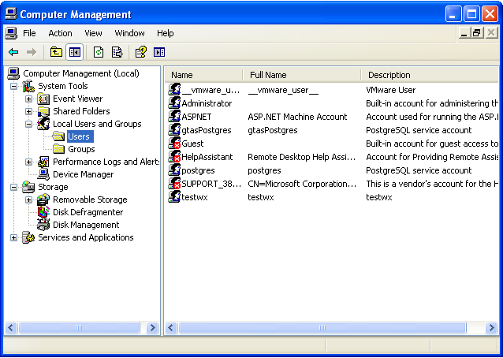

- Add new user by right clicking the user list view panel.
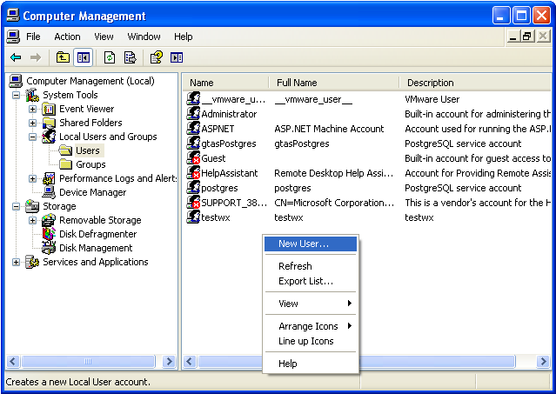

- Specify the new user account detail as below. For the password, enter “gtas2020!”
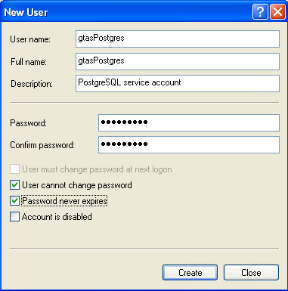

The new user account “gtasPostgres” is created.

- Grant permission to the user “gtasPostgres” we created previously to have modify/write access to the folder %GRIDTALK_HOME%\db

- Go to the folder %GRIDTALK_HOME%\pgsql\bin via command prompt.
- Register the PostgreSQL as window services by executing the command below.

pg_ctl register -N pgsql-8.2 -P gtas2020! -U gtasPostgres -w -D "<PostgreSQL DB_DATA_DIR>"

<PostgreSQL DB_DATA_DIR> - The directory is under %GRIDTALK_HOME%\db for example “C:\etrade\GTBackup\GridTalk\db”

- Go to Services console under Control Panel\Administrative Tools to edit the service entry “pgsql-8.2” we just created. This will activate the newly created user account “gtasPostgre” to have the necessary right to start the Postgres services.

1. Under the tab “Log On”, re-entered the password as “gtas2020!”.
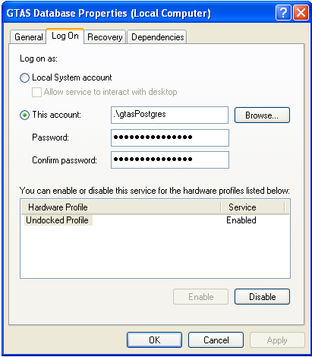

The following granted will be showed.

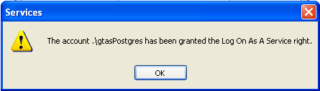

- Go to Registry configuration page to edit the “pgsql-8.2” entry. We will remove the un-necessary dependency and edit the info of the pgsql services.

- Startup the Registry Editor by running the following command in the command prompt.
regedit

- Navigate to the “Services” Folder under “My Computer\HKEY_LOCAL_MACHINE\SYSTEM\CurrentControlSet\Services”.

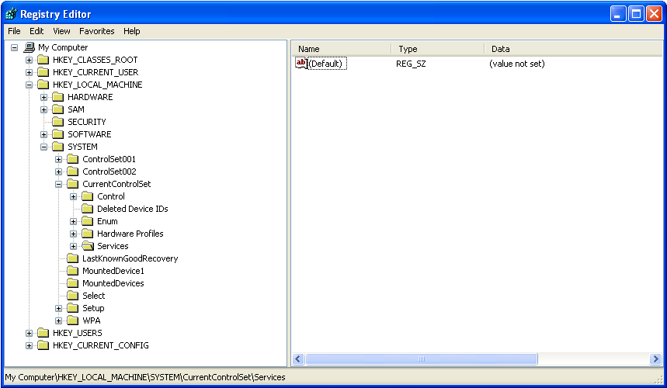

- Expand the “Services” and locate the window services “pgsql-8.2”.
- Modify the service entry “Display Name” by specifying “GTAS Database”.
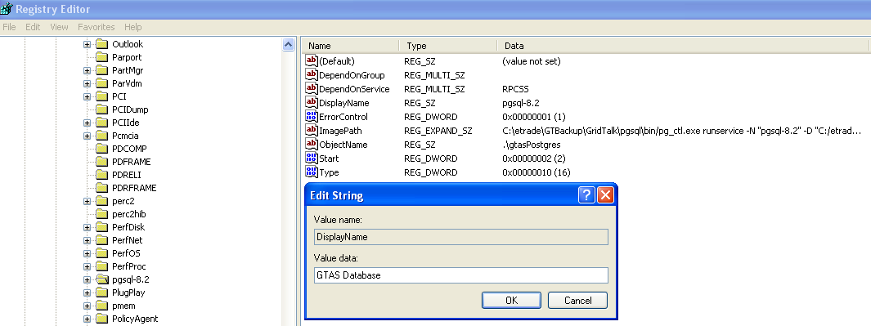

- Remove the service entry “DependOnGroup” and “DependOnService”. When prompting for deletion of the value, select “Yes”.
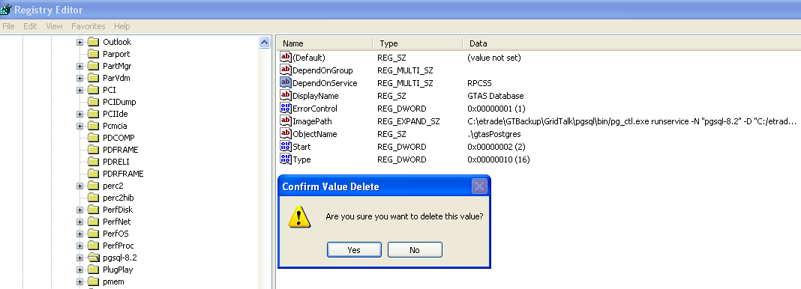

- Restart the Windows to take effect.

PostgresDB can now be started as services.

